**Final Assignment for Data Basics**

For the final assignment, you will be working on a hospital database with hospital related tables.

***List of tables in the hospital database:***

* physician
* department
* affiliated_with
* procedure
* trained_in
* patient
* nurse
* appointment
* medication
* prescribes
* block
* room
* on_call
* stay
* undergoes

We will be providing you with the data in CSV format. You will be creating tables and inserting data as illustrated by the ER diagram below.

**ER Diagram for the hospital table:**

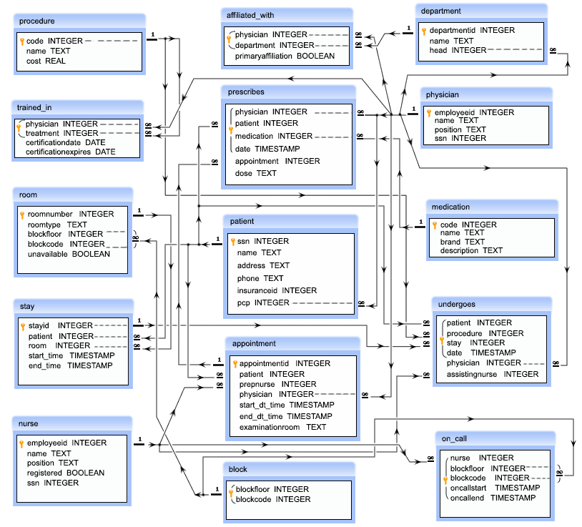

**Details of the tables:**

***physician:***

* employeeid – this is a unique ID of a physician
* name – this is the name of a physician
* position – this is the designation of a physician
* ssn – this is a security number of a physician

***department:***

* departmentid – this is a unique ID for a department
* name – this is the name of a department
* head – this is the ID of the physician who is the head of a department, referencing to the column employeeid of the table physician

***affiliated_with:***

* physician – this is the ID of the physicians which is referencing to the column employeeid of the physician table
* department – this is the ID the department which is referencing to the column departmentid of the department table
* primaryaffiliation – this is a logical column which indicate that whether the physicians are yet to be affiliated or not
* *Note: The combination of physician, department will come once in that table.*

***procedure:***

* code – this is the unique ID of a medical procedure
* name – the name of the medical procedure
* cost – the cost for the procedure

***trained_in:***

* physician – this is ID of the physicians which is referencing to the column employeeid of the physician table
* treatment – this is the ID of the medical procedure which is referencing to the column code of the procedure table
* certificationdate – this is the starting date of certification
* certificationexpires – this is the expiry date of certification
* *Note: The combination of physician and treatement will come once in that table.*

***patient:***

* ssn – this is a unique ID for each patient
* name – this is the name of the patient
* address – this is the address of the patient
* phone – this is the phone number of the patient
* insuranceid – this is the insurance id of the patient
* pcp – this is the ID of the physician who primarily checked up the patient which is referencing to the column employeeid of the physician table

***nurse:***

* employeeid – this is the unique ID for a nurse
* name – name of the nurses
* position – the designation of the nurses
* registered – this is a logical column which indicate that whether the nurses are registered for nursing or not
* ssn – this is the security number of a nurse

***appointment:***

* appointmentid – this is the unique ID for an appointment
* patient – this is the ID of each patient which is referencing to the ssn column of patient table
* prepnurse – the ID of the nurse who may attend the patient with the physician, which is referencing to the column employeeid of the nurse table
* physician – this is the ID the physicians which is referencing to the employeeid column of the physician table
* start_dt_time – this is the schedule date and approximate time to meet the physician
* end_dt_time – this is the schedule date and approximate time to end the meeting
* examinationroom – this the room where to meet a patient to the physician

***medication:***

* code – this is the unique ID for a medicine
* name – this is the name of the medicine
* brand – this is the brand of the medicine
* description – this is the description of the medicine

***prescribes:***

* physician – this is the ID of the physician referencing to the employeeid column of the physician table
* patient – this is the ID of the patient which is referencing to the ssn column of the patient table
* medication – the ID of the medicine which is referencing to the code of the medication table
* date – the date and time of the prescribed medication
* appointment – the prescription made by the physician to a patient who may taken an appointment which is referencing to column appointmentid of appointment table
* dose – the dose prescribed by the physician
* *Note: The combination of physician, patient, medication, date will come once in that table.*

***block:***

* *blockfloor – ID of the floor*
* *blockcode - ID of the block*
* *Note: The combination of blockfloor, blockcode will come once in that table.*

***room:***

* *roomnumber – this is the unique ID of a room*
* *roomtype – this is type of room*
* *blockfloor - this is the floor ID where the room in*
* *blockcode – this is the ID of the block where the room in*
* *unavailable – this is the logical column which indicate that whether the room is available or not*
* *Note: The of blockfloor, blockcode columns are refercing to the combination of blockfloor and blockcode columns of the table block.*

***on_call:***

* *nurse – this is ID of the nurse which is referencing to the employeeid column of the table nurse*
* *blockfloor - this is the ID of the floor*
* *blockcode – this is the ID of block*
* *oncallstart - the starting date and time of on call duration*
* *oncallend – the ending date and time of on call duration*
* *Note: The combination of nurse, blockfloor, blockcode, oncallstart, oncallend will come once in that table and the combination of blockfloor, blockcode columns are refercing to the combination of blockfloor and blockcode columns of the table block .*

***stay:***

* *stayid - this is unique ID for the admission*
* *patient – this is the ID of the patient which is referencing the ssn column of patient table*
* *room - this is the ID of the room where the patient admitted and which is referencing to the roomnumber column of the room table*
* *start_time – this is the time when a patient admitted*
* *end_time – this is the time how long a patient is staying*

***undergoes:***

* patient - this is ID of the patient which is referencing to the ssn column of the patient table
* procedure – this is ID of the procedure and referencing to the code column of the procedure table
* stay - this is the ID admission of a patient, which is referencing to the stayid column of the stay table
* date – this is the date when a patient undergoes for a medical procedure
* physician – this is the ID of a physician which is referencing to the column employeeid of the table physician
* assistingnurse – this is the ID of a nurse who will assists the physician, referencing to the column employeeid of the table nurse
* *Note: The combination of patient, procedure, stay, date will come once in that table.*

**Questions:**

1. Write a query in SQL to obtain the name of the physicians who are the head of each department.
2. Write a query in SQL to count the number of patients who booked an appointment with at least one physician.
3. Write a query in SQL to obtain the name of the physician and the departments they are affiliated with.
4. Write a query in SQL to count the number of available rooms.
5. Write a query in SQL to obtain the name of the physicians who are trained for a special treatment.
6. Write a query in SQL to obtain the name of the physicians with departments who are yet to be affiliated.
7. Write a query in SQL to obtain the name of the physicians who are not a specialized physician.
8. Write a query in SQL to find the name of the patients and the number of physicians they have taken appointments.
9. Write a query in SQL to count the number of unique patients who got an appointment for examination room C.
10. Write a query in SQL to find the name of the nurses and the room scheduled, where they will assist the physicians.
11. Write a query in SQL to find the name of patients and their physicians who does not require any assistance of a nurse.
12. Write a query in SQL to obtain the name of the patients, their block, floor, and room number where they are admitted.
13. Write a query in SQL to find the name of the patients who took an advanced appointment, and also display their physicians and medication.
14. Write a query in SQL to find the name and medication for those patients who did not take any appointment.
15. Write a SQL query to obtain the names of all the physicians performing a medical procedure but they are not certified to perform.
16. Write a query in SQL to obtain the names of all the physicians, their procedure, date when the procedure was carried out and name of the patient on which procedure have been carried out but those physicians are not certified for that procedure.
17. Write a query in SQL to Obtain the names of all patients who has been prescribed some medication by his/her physician who has carried out primary care and the name of that physician.
18. Write a query in SQL to obtain the nurses and the block where they are booked for attending the patients on call.
19. Write a query in SQL to make a report which will show -
    1. name of the patient,
    2. name of the physician who is treating him or her,
    3. name of the nurse who is attending him or her,
    4. which treatment is going on to the patient,
    5. the date of release,
    6. in which room the patient has admitted and which floor and block the room belongs to respectively.
20. Write a query in SQL to obtain the names of all the nurses who have ever been on call for room 122.